# COMP 3512 Assignment #1: Data-Driven PHP *(version 2b)*

#### Due Monday October 24th Noonish

## Overview

This assignment provides an opportunity for you to demonstrate your ability to generate dynamic web pages from database content using PHP. In this assignment you will be working with the Art case study from the textbook.

## Submitting

Put your assignment in a folder named assign1_*yourlogin* (e.g., assign1_fsmi9876). Put all resources used by your assignment into this folder. Copy this folder to the submit drive in B215 **and** to the normal university-wide submit drive. You will lose marks if you do not follow these submission instructions.

## Grading

The grade for this assignment will be broken down as follows:

Visual Design and Styling 10%

Programming Design 15%

Functionality (follows requirements) 70%

## Data Files

You have been provided with the necessary SQL script that you will need to import into MySQL (easiest to use PHPMyAdmin). Importing a SQL file can, depending on the size and complexity of the tables and the speed of your computer, take a minute or two. Unfortunately, the default settings of XAMPP may prevent you from successfully importing the data. You may need to change the configuration settings for both MySQL (my.ini) and PHP/Apache (php.ini), and then restart XAMPP. Do a Google search to find the relevant settings to change.

You have also been provided with a Microsoft Access version of the database which is useful for easily examining the data or creating queries in a drag-and-drop environment. Also, various image files have also been provided for you.

## Requirements

This assignment consists of 12 pages with the following functionality:

1. You must make use of the Semantic UI Framework (http://semantic-ui.com/) to style and layout your pages. Like with Bootstrap, this framework does have a little bit of a learning curve; eventually however you will find that it makes your life as a web developer significantly easier since you will be able to concentrate on programming and let Semantic UI handle the CSS. I have chosen it because it seems to be the third-most popular CSS framework (after Bootstrap and Foundation) but the pages you can produce with it look more stylish, more evocative of 2016 design rather than the 2012-look of Bootstrap. As well, Semantic UI has a much richer set of styles and components. This can make it a bit intimidating at first. I would recommend starting by using grids, items, segments, buttons and images to create a basic page. Take a look at the basic layout examples they provide (http://semantic-ui.com/usage/layout.html).
2. I have provided a completed page; your other pages should “fit” with this design. [visual design worth 10 marks]
3. The site **must** use a single CSS file for any additional text and color formatting.
4. All pages **must** have six links: to index.php, aboutus.php, browse-artists.php (not implemented), browse-paintings.php , and browse-genres.php pages. Add these links to the Browse submenu in the header. Notice as well the link expectations for the header area; these must be consistent on all pages.
5. You will need to write database access code for most of your pages in this assignment. The programming design component of the grade [worth 15%] will in large part be determined by how you structure this database access. Remember that the preference is for markup that has minimal programming logic within it.

I would also strongly recommend creating the following pages in the order provided below.

1. This page must be named index.php and must be the destination for any Home links in your site. The text and links for the images on the home page can be hard-coded; I have already provided a partial version of this page called index.html. You will have to set the link for the “Shop Now” button to browse-paintings.php. You will also have to define three Semantic UI Cards, with the links single-genre.php with the appropriate query string. The images are from the medium folder. This page requires no PHP programming. Its intent is to get you familiar with using the Semantic UI framework.

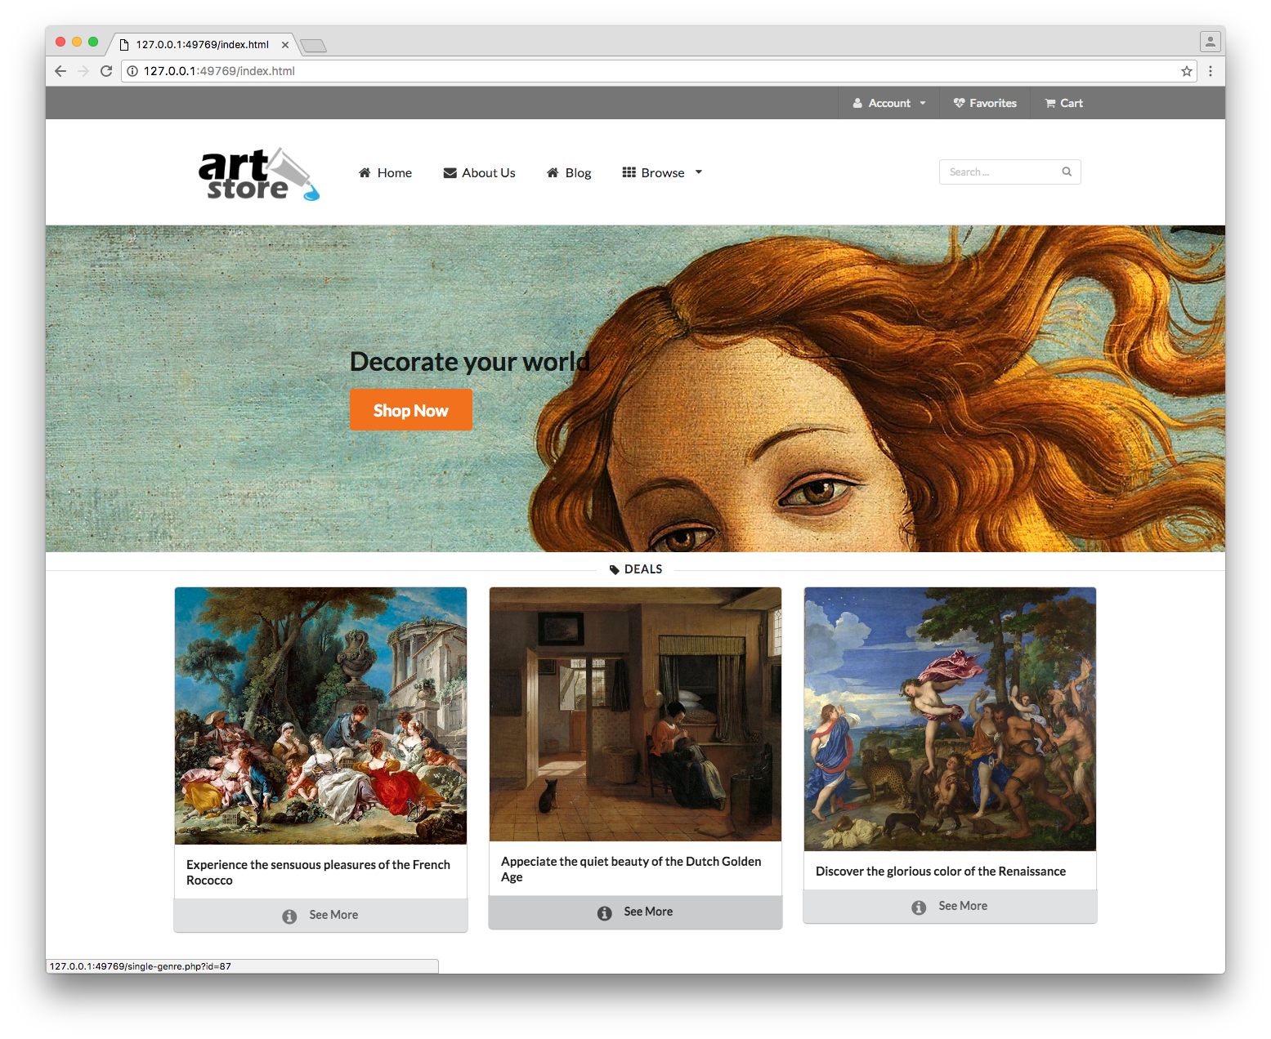

1. This page must be named aboutus.php. It should have your name, the course name and number, date, and anything else you’d like to put here. Somewhere on this page, provide a list of all resources you are using that you did not create (e.g. SemanticCSS, images, etc). Try to make it look nice.
2. This page must be named single-painting.php. It must display the information about a single painting (specified via the id passed in via a query string parameter). This page has a lot of information packed into it which will require using the SemanticUI Tab module to fit it all in. You have been provided with a partial HTML version that you can modify (and also help learn the framework). The artist and genres should be workable links to single_artist.php and single_genre.php with the appropriate querystring.   
     
   This page needs to display data from some other tables (Gallery, Genres, and Reviews). The Frame, Glass, and Matt select lists should be populated from the appropriate tables. Don’t worry about Subjects data or subjects tab.  
     
   Be sure to use the PHP utf8_encode() function to properly display some of the foreign characters in the data.  
     
   For the stars under the artist name, just leave as is. In the next assignment we will calculate those.

The image must be a link to the large version. This page should handle a missing or a non-integer query string parameter by displaying a default painting.

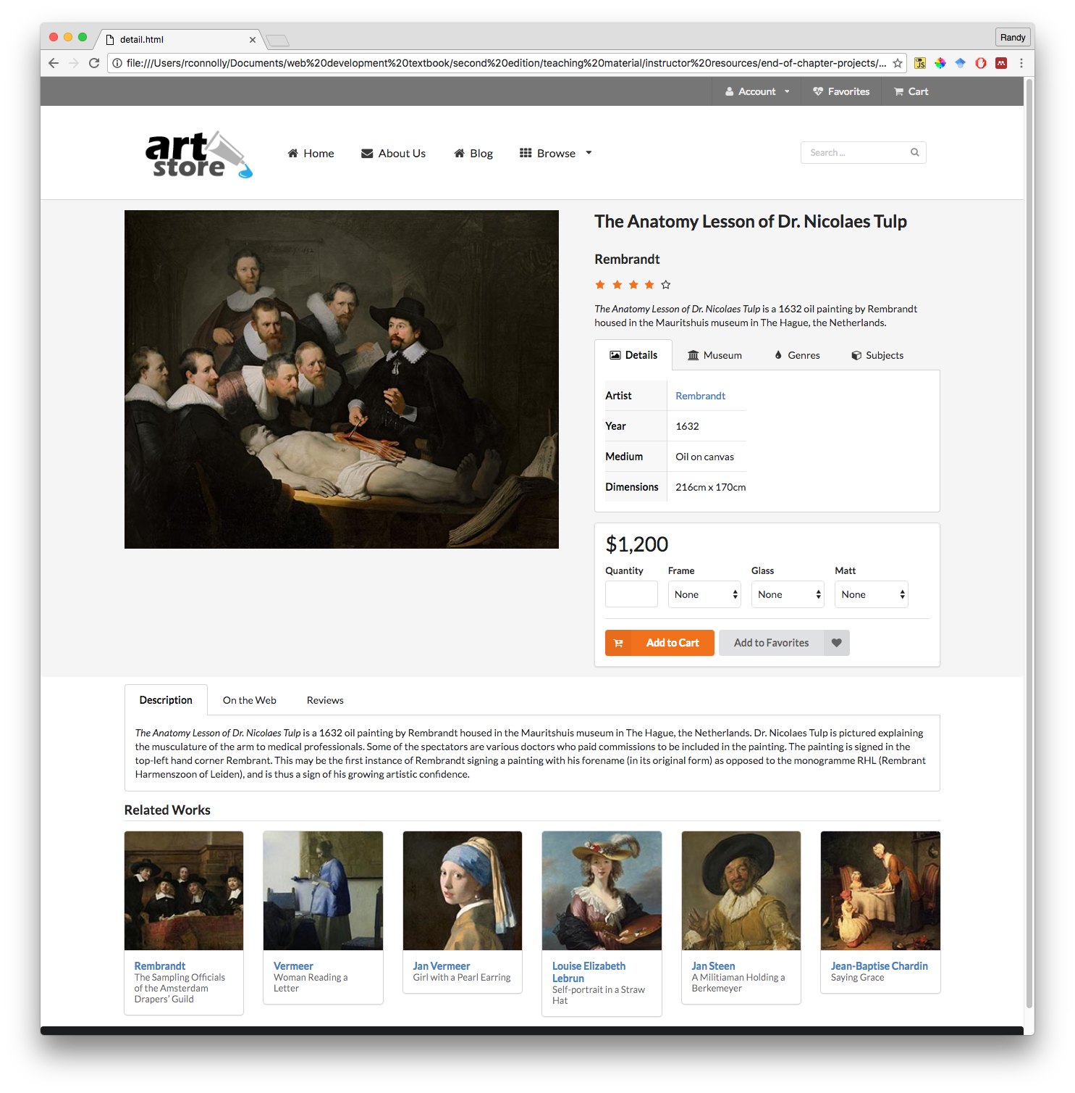

1. This page must be named browse-paintings.php. This page displays multiple paintings sorted by year (the oldest paintings should appear first). Because there are hundreds of paintings, only show the top 20. Each of the images shown must be links with the appropriate query string to the single-painting.php page.   
     
   Initially, this page must display all the paintings in the painting table. The user should be able to filter the list by specifying the artist or museum or shape in the three drop-down lists, populated from the artists (sorted by last name), museums (sorted by gallery name), and shapes (sorted by shape name) tables. As with the unfiltered list, only display the top 20 matches for the filter. To simplify your programming, assume that the user will filter only by one of artists, museums, or shapes.

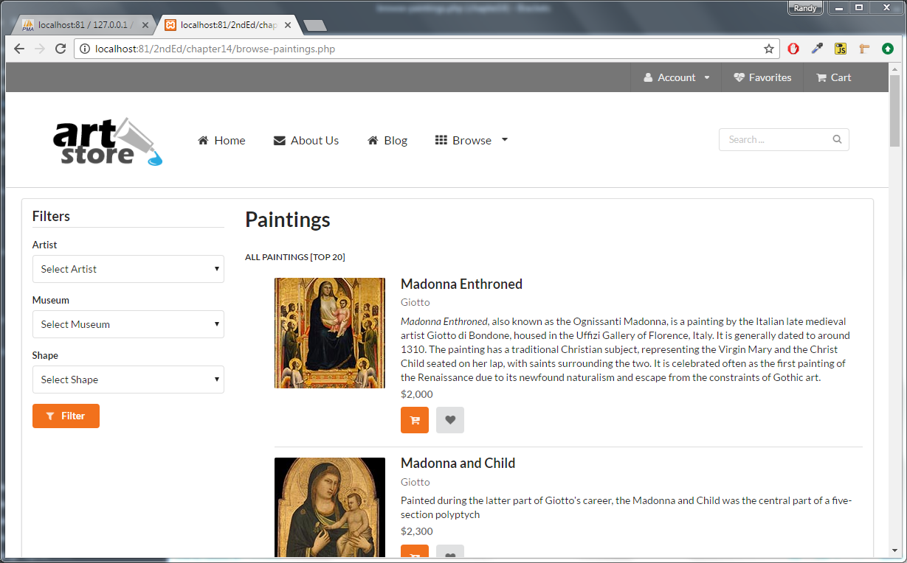

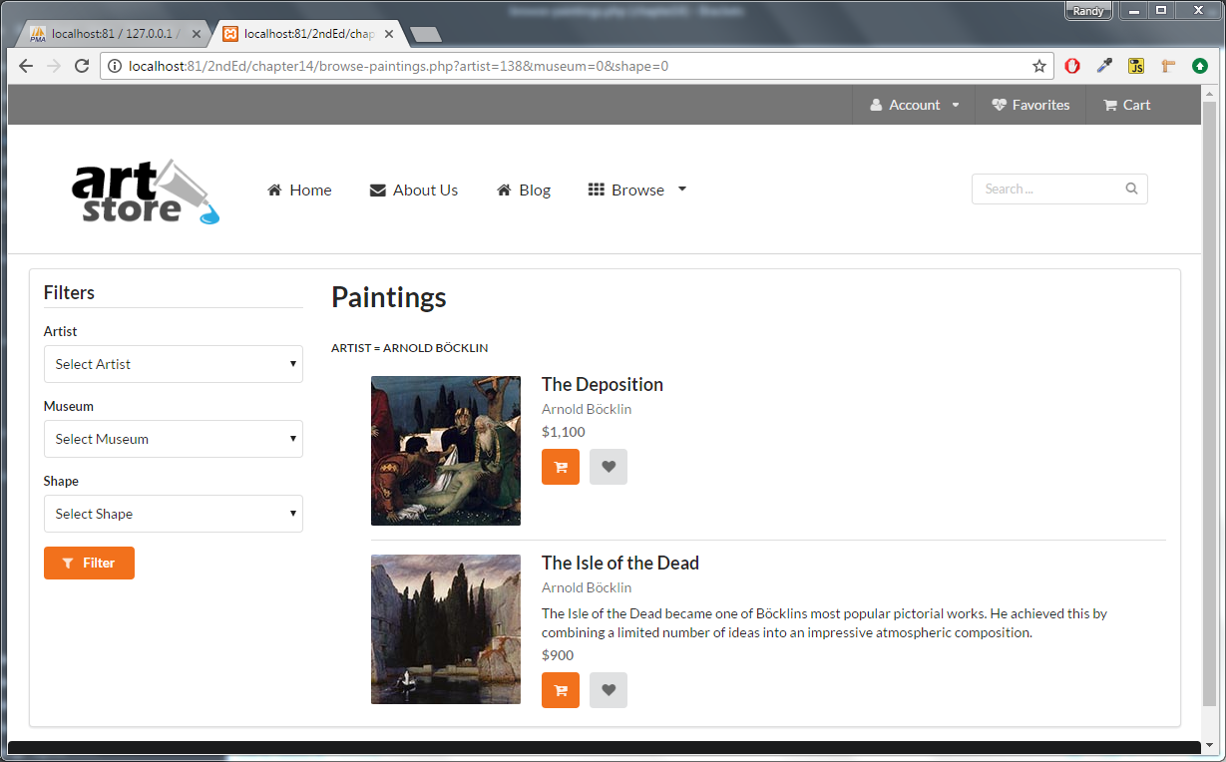

1. This page must be named browse-genres.php. Each genre has an associated image with which you can construct a list of images (sorted by EraID then by genre name). Each genre in this list should be links to single-genre.php with the appropriate querystring.

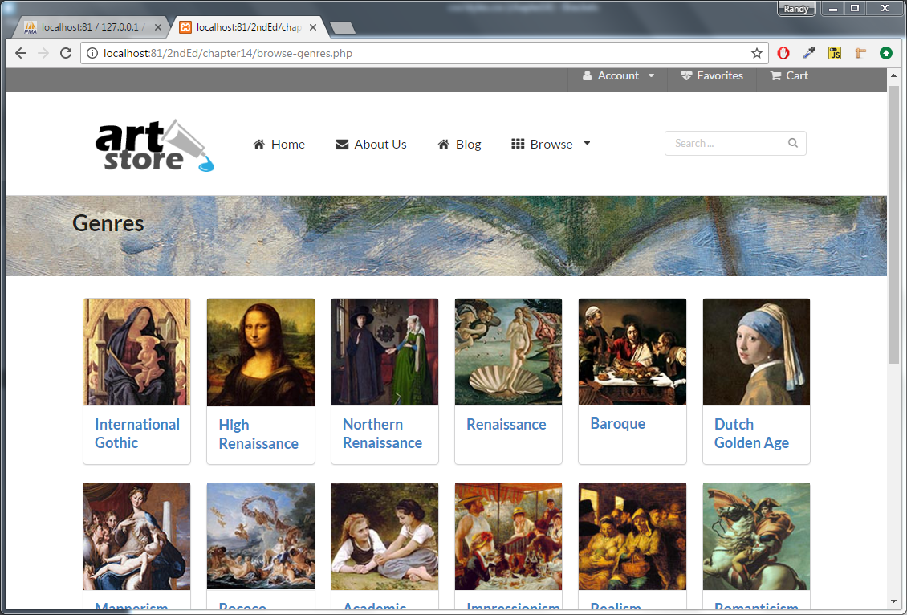

1. This page must be named single-genre.php. It must display the information about a single genre (passed in via a query string parameter). The paintings panel should show the paintings for that genre sorted by year. Each image should be a link to single-painting.php with the appropriate querystring (the same will be true in any other page that contains square-medium images). You should generalize this functionality as you will need to display lists of paintings for other pages as well. This page should handle a missing or a non-integer query string parameter by displaying a default genre.

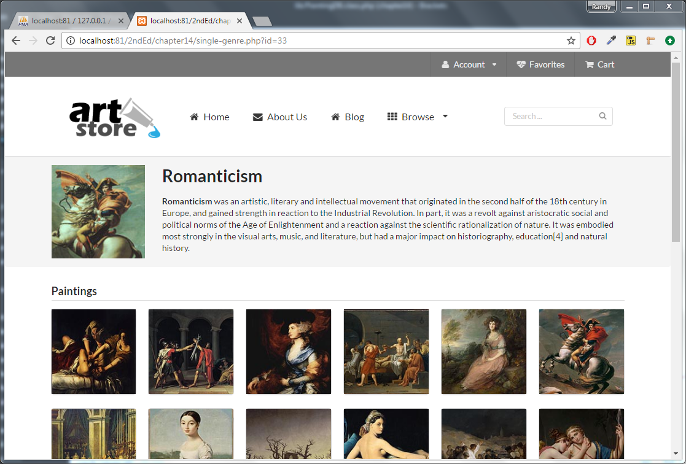

1. This page must be named single-artist.php. It should display information for the specified artist (specified via a query string parameter) from the artists table. You may need to use the PHP utf8_encode() function to properly display some of the foreign characters in the artist data. The page should also have a paintings panel that shows the paintings by that artist sorted by year. Each image should be a link to single-painting.php with the appropriate querystring. This page should handle a missing or a non-integer query string parameter by displaying a default artist. Design this page how you like but it should fit with the rest of the site.